**September.10th**

**Picture Day**

Bring your brightest smiles!

**September.11th**

**Stand Up Against Bullying – Pink Day**

On the second Thursday of September, we recognize Stand Up Against Bullying Day. OnThursday, September 11th, we will celebrate inclusivity, kindness and friendship. All HRCE school teams are focused on ensuring all students have a safe and welcoming environment in which to learn and thrive.

Please wear pink if you’re able on September 11 to take a stand against bullying.



**September.18th**

**Curriculum Night**

Families of Grade Primary-Five students are welcome to join our Curriculum Night event from 6PM-7PM. Families are invited to visit their child(ren)’s classrooms and participate in a scavenger hunt, ending with a cold treat for students!

**September.26th**

**Orange Shirt Day**

Orange Shirt Day within the Halifax Regional Centre for Education (HRCE) is observed annually to recognize and remember the children who attended residential schools. Orange Shirt Day, led by Indigenous communities, aims to raise awareness about the inter-generational impacts of residential schools and allows us all to show our support for the Every Child Matters movement. As there are no classes on Monday, September 29 and Tuesday, September 30, we welcome staff and students to wear orange on Friday, September 26.

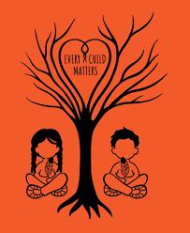

**September.29th**

**Professional Development Day**

No classes for students.

**September.30th**

**National** **Day** **for Truth and** **Reconciliation**

Each year on September 30, National Day for Truth and Reconciliation honours the children who didn't return from residential schools, as well as survivors, their families, and communities. The day provides an opportunity to reflect on the history and ongoing impacts of these institutions.

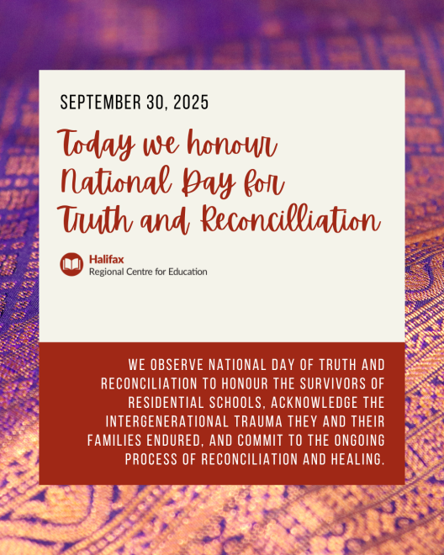

**Wishing everyone a spectacular September!**

**~PRES**